Name: Ryan Peters Collaborators: (Any one you worked with)

R Lab 3: Probability

Please answer all the Exercises and the questions from the “On Your Own” section. If you use any graphs or charts to justify your answer, please include them.

Exercise 1:
What does a streak length of 1 mean, i.e. how many hits and misses are in a streak of 1? What about a streak length of 0?
A streak of 1 indicates that Kobe had a single hit before he had a miss. A streak of 0 indicates that he had zero hits before making another miss.
E.G.
M: streak length 0
HM: streak length 1
HHM: streak length 2
…
HHHHHHHM: streak length 7
Exercise 2:
Describe the distribution of Kobe’s streak lengths from the 2009 NBA finals. What was his typical streak length? How long was his longest streak of baskets?

Kobe’s streak performance appears to be a right-tailing negative log curve.
His typical streak length was 0, more on that later.
His longest was a streak of 4 hits.
Follow up on Kobe’s most frequent streak length:
Hits, and Hit streak ratios:
length(kobe$basket[which(kobe$basket=='H')])/length(kobe$basket)
58/133 = 0.4360902
length(kobe_streak[which(kobe_streak!=0)])/length(kobe_streak)
37/76 = 0.4868421
Miss, and Miss streak ratios:
length(kobe$basket[which(kobe$basket=='M')])/length(kobe$basket)
75/133 = 0.5639098
length(kobe_streak[which(kobe_streak==0)])/length(kobe_streak)
39/76 = 0.5131579

From these ratios we can see that the ratio of missed shots to any length of streak is significantly more biased towards a miss than any form of ‘hot-streak’.

Exercise 3:
In your simulation of flipping the unfair coin 100 times, how many flips came up heads?

It came up 21 times apparently. So not exactly 20%, but after enough iterations it trends towards

Exercise 4:
What change needs to be made to the sample function so that it reflects a shooting percentage of 45%? Make this adjustment, then run a simulation to sample 133 shots. Assign the output of this simulation to a new object called sim_basket.

sim_basket <- sample(outcomes,size=133, replace=TRUE,prob=c(.45,.55))

On Your Own:
1) Describe the distribution of streak lengths. What is the typical streak length for this simulated independent shooter with a 45% shooting percentage? How long is the player’s longest streak of baskets in 133 shots?

The other shooter’s distribution of streaks looks to be a right tailing curve that approximates a
negative exponential curve. Typical streak length is 0, and the longest streak is 6.
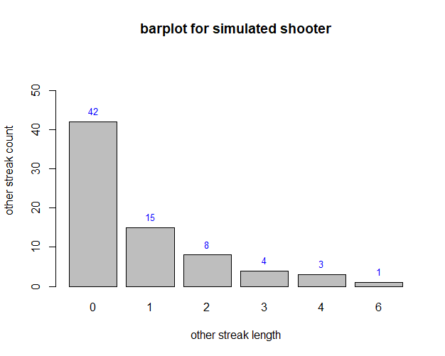

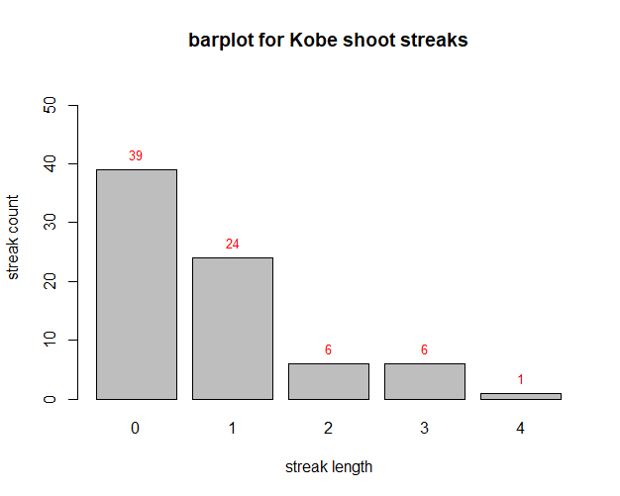

2) If you were to run the simulation of the independent shooter a second time, how would you expect its streak distribution to compare to the distribution from the question above? Exactly the same? Somewhat similar? Totally different? Explain your reasoning.

I would expect it to be somewhat similar. The values will likely vary across the board, but only by small amounts, as the sample size of 133 is small enough for potential extreme values in the random sampling to cause significant variations in the expressed data still.

3) How does Kobe Bryant’s distribution of streak lengths compare to the distribution of streak lengths for the simulated shooter? Using this comparison, do you have evidence that the hot hand model fits Kobe’s shooting patterns? Explain.

Kobe’s streak distribution shows that he has a higher likelihood to actually hit streaks of 1 than the simulated shooter. This means that he’s more likely to miss a shot that follows one that hit.

It is also apparent that Kobe’s maximum streak length is much less than that of the simulated shooter. Where Kobe’s longest streak was 4, the simulated shooter’s was 6.

Using this evidence, it’s apparent that Kobe actually has something that looks like the opposite of the hot hand model. It’s more like a single use pistol where he needs to cycle in a miss to ‘reload’ his hands

